**Rational Quality Manager**

**Quick Start Tutorial**

**Ration**

Page Left Intentionally Blank

**Table of Content**

1. Introduction 5

2. Terminology 5

3. Logging in to Rational Quality Manager 5

4. Project Area Preparation 6

4.1 Adding Users and specifying Roles 6

4.2 Managing Tool Associations 7

5. Test Planning 9

5.1 Creating the Test Plan 9

5.2 LINK Defining Entry Criteria, Exit Criteria and Quality Objectives 12

6. Testing for Requirements 15

6.1 Creating the Test Environments 15

6.2 Adding Requirements 19

6.3 Adding Test Cases 20

6.4 Running Test Cases 24

6.5 Viewing Test Case Execution Records 27

7. Adding a Widget 28

7.1 Procedure 28

8. Best practices 30

8.1 Defining Weight 32

8.2 Snapshots 33

8.3 Copy Utility 34

8.4 One Test Script per Test Case 34

8.5 Entry criteria and Exit criteria 34

8.6 Using Keywords, Test Data and Execution Variables 35

8.7 Run Test Cases 36

8.8 Run Test Suites 36

8.9 Run test case execution records and test suite execution records 37

Page Left Intentionally Blank

# Introduction

Rational Quality Manager empowers teams to manage the quality lifecycle of a project by defining test cases, sharing information and reporting project metrics.

This tutorial explains the basic features and helps getting started with Rational Quality Manager.

More information is available in the online library of Jazz.net: https://jazz.net/library

# Terminology

**Test Plan:** A document detailing a systematic approach to testing a system.

**Test Case:** a set of conditions or variables under which a tester can determine whether an application or software system is working correctly or not.

**Test Script:** a set of instructions that is performed on the system under test to test that the system functions as expected.

**Test Environment:** a setup of software and hardware on which the testing team performs the testing of the software product.

**Defect:** It is a condition in a software product which does not meet a software requirement or end-user expectations.

# Logging in to Rational Quality Manager

1. Start the product and log in using a URL supplied by administrator.

NOTE

Before start using the product, administrator must start the Jazz™ Team Server.

1. In a browser window, type the URL supplied by administrator.

* https://<Server name>:<Port number>/qm/web

Server name is either the host name of Jazz Team Server or an IP address and Port number is the port number on that server and project is a project area on the server. By default, the port number is 9443. For example,

* <https://ra-clmqm01.siemens.net:9443/qm/web>
* From Quality Management 🡪 All Project – Choose the project name
* To login into the Home page of a project the sample url is below
* For example The project name is “Automation CLM project”
* https://ra-clmqm01.siemens.net:9443/qm/web/console/Automation%20CLM%20project%20(Quality%20Management)#action=com.ibm.rqm.planning.home.actionDispatcher&subAction=viewUserHome

1. At the log in screen, type the User ID and password that received from the administrator.
2. Click Log In.

# Project Area Preparation

Before starting the project, it is advisable to configure the team and project area.

All of the following tasks require the user to go to the Application Administration page, which can be done as follows:

1. Click on the Administration icon  and then click Manage This Project Area.



## Adding Users and specifying Roles

Create a project area as an administrator, add members and specify the roles of each of these members.

1. On the Application Administration page of the web client, click the Overview tab.
2. Add the members that are related to the project. To add members do the following:

* In the Members pane, click Add.
* In the Contributor Selection window, enter the name of a user to search for, or click Show All. Remember to use the name or last name of the user instead of the user id.
* In the Matching users pane, select a user.
* Click Add.

1. Specify the roles of each member. To specify a role do the following:

* Choose the user in the Members pane; click the Process Roles icon on the Actions column.
* In the Edit Process Roles window, select the desired role(s) in the Available Roles list, click Add -->.
* Click OK.



1. Click Save.

## Managing Tool Associations

Rational Products is interconnected and other tools, such as Rational Requirement Composer and Rational Team Concert provide services to Rational Quality Manager. This tutorial shows some of these connections.

1. On the Application Administration page of the web client click the Overview tab.
2. Go to the Associations section. Check that the following associations are added:

* Defects -> Change and Configuration Management (Rational Team Concert).
* Quality Management Tasks -> Change and Configuration Management (Rational Team Concert).
* Requirements -> Requirements Management (Rational Requirements Composer).



1. If they are not added click Add.
2. On the Add Association view choose the Application, choose the right Association (from the ones listed on step 2) and choose the project from the list of artifact containers. Click OK. Repeat for all the missing associations.



1. Click Save.

# Test Planning

Create test plans in order to guide the quality managing work. A test plan in RQM has numerous options; this tutorial presents an overview of the most commonly used aspects of the test plan.

## Creating the Test Plan

1. In the Project Dashboard view, expand the Planning Menu and click the Create Test Plan.



1. In the Test Plan view, see the following:

* The attributes of name, action, owner, priority and description of the test plan in the overview section. Choose the desired values for these attributes and change the template or leave it as “Default Test Plan”.
* A table of contents on the left column that lists all the sections of the test plan. Click the Manage Sections to add, remove, create and edit sections as per the requirement.
* In the detail section, in the working area of each section, click open from the table of contents.



1. In each section create and link tasks in order to keep track to do the following.

* Click on Quality Task: Create
* On the Create Quality Task view, fill the attributes (some are already filled with default values), set a due date and click OK. Now see the link to the newly created quality task next to the Quality Task label of the section which is being linked to the that section. This quality task is a work item on another Rational tool called Rational Team Concert.



1. Click Save in order to save the project plan and task associations.

## LINK Defining Entry Criteria, Exit Criteria and Quality Objectives

On the Test Plan define Entry Criteria that lists the objectives that have to be met in the project before starting with the current test plan. The Exit Criteria that lists the objectives that have to be met in order to finish the Test Plan successfully. Finally the Quality Objectives list the metrics that the product must reach in order to be considered a quality product.

1. In the Test Plan view click Entry Criteria.
2. Click the Manage Quality Objectives button.
3. On the Manage Quality Objectives view, see a list of predefined objectives. Add or Remove new objectives by clicking the corresponding buttons to add and to  remove. Add the objectives for the entry criteria of current plan. Click Save and close the Manage Quality Objectives view. This opens the open view.
4. In the open view, click the Add Objectives button.
5. On the Select Quality Objectives window click the objective to add and click OK. The objective is added to the Entry Criteria objectives list. Repeat for all the objectives to add to Entry Criteria.



1. Click Save.
2. Then each objective is evaluated by changing its Actual Value and Status.



1. Repeat Steps 1 to 7 on the Exit Criteria Section and the Quality Objectives Section with the proper objectives for each section.

# Testing for Requirements

Rational Quality Manager is linked to various tools such as Rational Requirements Composer in order to import or create Requirements that need to be tested. These requirements are linked to test cases and each test case has a number of test scripts.

## Creating the Test Environments

On the Test Environments Section, add the different environments under which the application is tested. This includes various platforms such as browsers, databases, operating systems and other items.

1. In the Test Plan view click Test Environments.



1. First add all the platforms that are covered on the test plan. Combinations of these platforms will then be used to generate test environments.

* On the Platform Coverage Tab click the Edit button.
* See a list of all the environment options, which includes browsers, operating systems, databases, etc. Choose the platforms as per the requirement to support and add them by clicking the Add button.



* Click OK. On the Platform Coverage tab and see a summary of the platforms chosen.
* Click the Save.



1. Now create the test environments by combining the selected platforms.

* On the Test Environment Tab click the Generate new tests environments button.
* In Step 1 of the Generate Test Environments view choose the platforms as per the requirement to use for the test environments and the coverage, which is how the combination of these platforms takes place. Then click Next.



* In Step 2 of the Generate Test Environment view, remove some undesired test environment configurations as per the requirement. In order to do this, select the test environments to remove and click the Remove button.



* Click Finish. On the Test Environment tab, see the list of the test environments; further edit them by adding descriptions to each test environment. Add more test environments or remove any test environment, as per the requirement.
* Click the Save.

## Adding Requirements

1. Expand the Requirements Menu, click Create Requirement.
2. On the Create Requirement View fill the attributes and click Finish. This will create a new Requirement on another Rational Tool called Rational Requirements Composer. Test all the Requirements in the Rational Requirements Composer project.



1. Repeat steps 1 and 2 in order to add all the requirements for test.
2. To further edit, add and remove Requirements, expand the Requirements Menu and click View Requirements, in which opens the Rational Requirements Composer.

## Adding Test Cases

1. Go back to Test Plan.
2. Click Test Cases.
3. Click the Create Test Case button.
4. On the create Test Case view add a Name and a Description for the Test case. Add a Weight. This weight indicates the complexity (and consequently, the duration) of the test. See section 8.1, Defining Weight, for more information about the weight of a test case.
5. Choose the template (for now Default Test Case Template) and click OK.



1. Click the Save.
2. Click the ID or the Name of the test case to open the Test Case View. In the Test Case View and see the following:

* The attributes of name, action, owner, priority, owner in the overview section and description of the test case. Edit these attributes, if necessary.
* All the sections of the test case in the table of contents on the left column. Click Manage Sections to add, remove, create and edit sections as per the requirement.
* The working area of each section in the section detail and click to open from the table of contents.



1. First, link the Test Case to one or more Requirements:

* Click Requirement Links.
* Click the Add new Links Button.
* On the Requirements Links View find the Requirement(s) to test using these, as per the requirement Test Case and click OK.



1. Now, add test scripts for the different scenarios of the test case. On Rational Quality Manager, create both manual test scripts and automated scripts. Since the project is not linked to an automatic testing tool. Focus on manual test scripts. In order to add a test script perform the following steps:

* Click the Test Scripts.
* Click the Create New Test Script button.
* Add a Name and Description for the test script and click OK.
* Click the Save.
* Click the ID or the Name of the test script to open the Test Script View. On the Test Script View, see:
* an Overview Section where you can change the Action, Owner, Test Data and Description of the Test Script.
* A Summary Section where you can change the Function and Test Phase attributes.
* The Formal Review Section where you can add reviewers and comments.
* Finally, the Manual Steps Section
* Click to Add Step. For each step on the script, the main attributes are a Description and the Expected Results. Each of the sections is a Rich Text editor view, so add more information such as attachments, images, comments, etc.
* Add all the steps of the current test script.



* Click Save.
* Repeat steps “Create New Test Script button” to “Save” in order to add all the desired test scripts.

## Running Test Cases

1. Go back to the Test Plan.
2. Click Test Cases.
3. Click the checkbox of the test case to run.
4. Click the Run Test Case button.
5. On the Run Test Case View, you can change some attributes of the test case execution. Choose a test script (from the ones created in step 5.3) and a test environment (from the ones created on step 5.1). Click OK.



1. The user is prompted to open the Test Execution View. See a Summary of the Test Script, the Preconditions and the Script Steps along with the controls to run them. Follow each step by logging the actual results and clicking the control button that shows the status of each step:  if the step is passed,  if the step is failed or  if the step is inconclusive. Run all the steps and for this example mark at least one as failed.



1. Click Show Result. This opens the Test Execution Result view. The first section is the Overview and the Results Detail section, where you see the summary of the execution, the actual result of the execution, the run time and other attributes.
2. Click Weight Distribution and see the distribution of the percentage of the results, this is used to show that the test case is not completely passed or completely failed (in this case). It is calculated automatically by the tool using the percentage of steps passed, failed and inconclusive, but it can be changed. For example, if one step is more important than others, its weight on the final result can be incremented.
3. Click Defects and link the test case execution to one or more defects. Since this test case was failed, add a defect by clicking the Create New Defect button.
4. On the Create New Defect view fill the attributes (some are already filled with default values), choose the project on the “Filed Against” attribute, choose a severity and a priority, extend the defect description and click OK. Now, see the link to the newly created defect on the list of the Defects section. This defect is a work item on another Rational tool called Rational Team Concert which then can be assigned to a developer who will fix the defect.



1. Click the Save.

## Viewing Test Case Execution Records

1. Go back to the Test Plan.
2. Click Test Case Execution Records and see the list of executions of test cases.



1. Click the ID or the Name of the test execution record to open, as per the requirement and see a summary of the execution of the test case.

# Adding a Widget

Add different types of widgets to a dashboard to display a variety of information.

## Procedure

1. Click the Add Widget ( ) icon in the upper-right corner of the dashboard. A Widget catalog opens and displays the available widgets grouped in categories. When a widget is selected, a description and a preview image are shown. Widgets are identified in the description.
2. After, finding the widget to add, select Add Widget. The widget is added at the top of the leftmost content column.

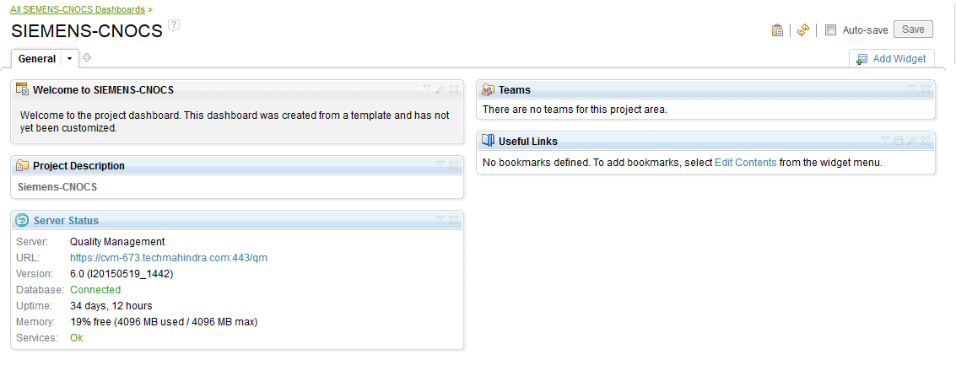

Add a widget to the dashboard, it is has a set of default settings and characteristics. Perform the following procedures to modify the widget's properties.

* Customizing the widget settings

Most widgets in the dashboard can be configured by specifying settings, such as Query, Results per page and URL. The settings determine the information that is displayed in the widget, either explicitly or by generating results based on values in the settings. The settings that are available for configuration are widget-dependent.

* To edit settings, open the widget menu and click Settings.
* Once the settings have been specified, select save to store them and return to the normal display state.
* Editing the content of a widget

Some widgets allow you to directly edit the content (for example, Bookmarks or HTML). If the content of a widget is editable, the Edit Contents ( ) icon is displayed in the widget title bar.

* To directly edit the content, select Edit Contents from the widget menu or click the Edit Contents () icon in the widget title bar. The actual editing steps depend on the way the widget has been designed. For example, an HTML widget allows you to directly edit HTML markup.
* After changing the content, select Save at the bottom of the widget to store the content and return to the normal display state.
* Changing the appearance of a widget
* To edit the appearance of a widget, open the widget menu and click Appearance. Change the following aspects of a widget:

**Title:** A default title is provided with each widget, modify the title to reflect the customized content and settings of the widget, as per the requirement. Click the Title text field and type a new title. Restore the widget's default title at any time by clicking the Restore default title arrow in the Title text field.

**Color trim:** Color trims allow to color-coordinate widgets based on the content they show and on the intent of dashboard.

Note

Make sure that the last choice in the list is no trim, which is particularly useful for the HTML widgets where free-form HTML can be used in various creative ways.

**Matching background color:** Setting Show Background Color displays a less saturated version of the trim color in the background of the entire widget. Background color can help organize a page that has many widgets. For example, using a background color on a single widget can make it stand out from other widgets on a page, and using the same background color for multiple related widgets can visually group them on the page.

* When you have finished modifying the widget's appearance, select Save to store the changes and return to the normal display state.
* Changing the scope of a widget

Some widgets are sensitive to the context in which they appear (scope). For example, the Plans widget shows different content when displayed in the project dashboard than in the team dashboard. Scope setting is automatically computed based on the dashboard but can be overridden in the Scope tab.

* To change this setting, open the widget menu and click Settings.
* Click the Edit button next to the scope field to open the Select Scope window.

Note

Make sure that only widgets sensitive to the scope have this preference displayed.

* Select Project and Team Areas or Users.

Select Project and Team Areas, then select a project or team area from the populated list.

Select Users, then search for a user by entering characters in the filter field or by clicking Show All. Only the first 250 matching user names are displayed in the Matching users box, so enter multiple characters in the filter field before that user name that you want appears in the Matching users box.

* Click OK to set the scope, and then click Save to save the new settings.

# Best practices

## Using test artifacts categories for organizing and generating effective reports:

This is a very good feature of RQM where the categories are defined for each of the test artifacts. Category is basically in an attribute of the test artifacts. Test artifacts are test cases, test suites, test plans, test scripts, or execution records. Test artifacts will physically help to group the test cases.

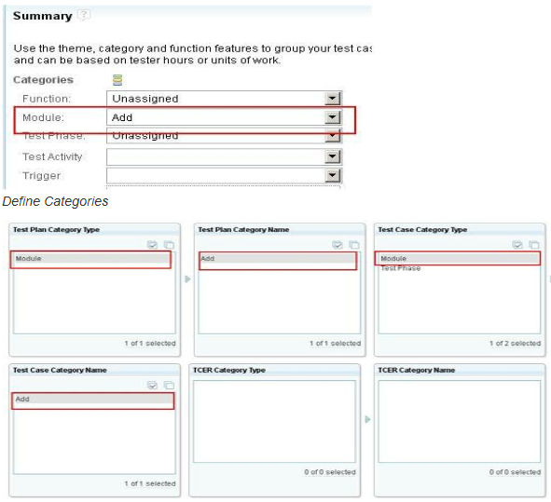

**Example1**

The Quality Assurance Team wants to create a report of the regression test runs. To identify the regression tests, a new value is defined for some category. The category may already exist or it could be created. For example, the value named “Regression” could be added to the “Function” category. The report can be configured to select the test cases where the “Function” category contains the value “Regression”.

A category can be designated as mandatory and/or multi-valued. A multi-valued category allows you to assign multiple values, for example, “Regression” and “Stress Test”.

**Example2**

There is an option in the report tool that allows you to select the test artifacts that are listed by selecting categories and values.

Select the required values to filter test artifacts and help to group them.

## Defining Weight

There is a useful category called “Weight.” Weight is basically a numeric indication of the complexity of the test case.

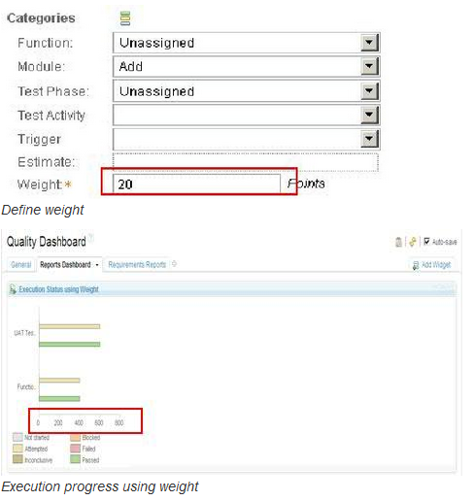

Define the weight attribute for each test case based on its complexity. If it is a simple test case then its weight could be assigned a value of 100 or if it is very complex test case then its weight could be 1000.

You will need to define a weight scale for the project. For example, you could define the scale to be 100-1000, with the rule that 100 means the test case is simple and only takes 2 minutes to execute, that 500 means it takes 5 minutes to execute and that 1000 means it takes 60 minutes or longer.

**Example1: Estimating the Testing Time Based on the Test Weight**

So based on the “Weight” category, you can group the test cases and report how many have a weight of 100, how many have a weight of 500, and how many have a weight of 1000. Based on this, you can estimate how much time it will take to execute the test cases. The time required is not a simple addition of weight values, but they define the complexity of the test cases, and based on that, define the timings.

**Example2: Estimating the Test Progress**

Consider a test suite with two test cases. One of the tests is simple and the other test is more complex. Suppose the simple test completes, but the complex test fails. If RQM uses the default weight values of 100, it calculates the test progress as 50%. If you assign the simple test a weight of 100 and the complex test a weight of 400, RQM calculates the test progress as 20%, which gives a better estimate of the remaining effort.

## Snapshots

Snapshots capture the state of all the artifacts in a component at a point in time. They are non-editable and do not replace the current baselines, which dynamically reflect the current state of all the artifacts in a component. A snapshot can serve as a reference of a previous version, but it does not provide true version management. RQM automatically creates snapshots before each build, but you can create additional snapshots any time.

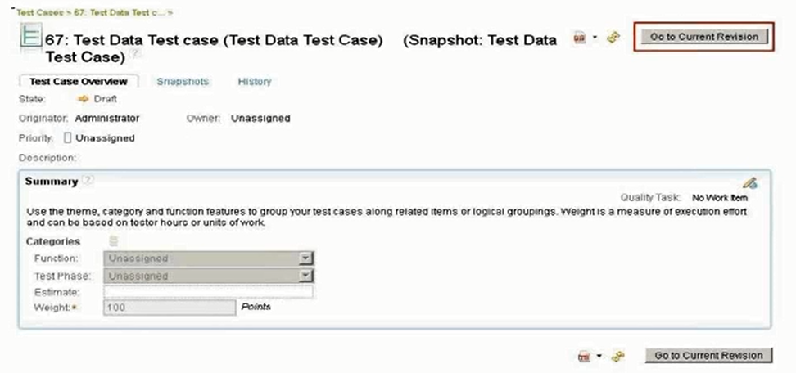

If you are working on a test plan or test cases and want to create a backup of the original files, you can create a snapshot. However, a snapshot is non-editable; you cannot modify anything in the snapshot of the test artifact, but you can view the artifacts in it if we need to refer the older copy. You can create a snapshot either in the same project area or in a different project area.

**Example1: Creating a Snapshot in the same Project Area**

In the same project area, creating a snapshot would basically create a reference of the previous test artifact. For example, if we create a snapshot of a test case and the test scripts, the snapshot won’t create new test scripts; it will refer to the test scripts which already exist for that particular test case.

**Example2: Creating a Snapshot in a Different Project Area**

Creating a snapshot in a different project area creates one with all the artifacts included. This is very useful when we want to maintain the old state of the test plan or test cases.

## Duplicate Tool

Using the Duplicate Tool, you can copy test artifacts into the same or a different project area to keep baselines of test artifacts.

You can treat previous artifacts as a baseline, and the new copied one as the current version. You can then start working on this new artifact. You can create references to the copied artifact by adding its RQM generated ID into some custom attribute fields, say Parent ID, which show where this new artifact was generated from.

In both the cases, using Snapshots or Duplicate, if you want to take a baseline of associated artifacts like test scripts and test cases, you need to do separate copy actions on those linked artifacts and link them to the newly created artifact according to your business needs.

Here the advantage of using Duplicate over Snapshots is that Duplicate creates a new copy, which we can edit. Snapshot is a read-only artifact, and cannot be modified. The screen shot below shows the use of Duplicate in RQM.

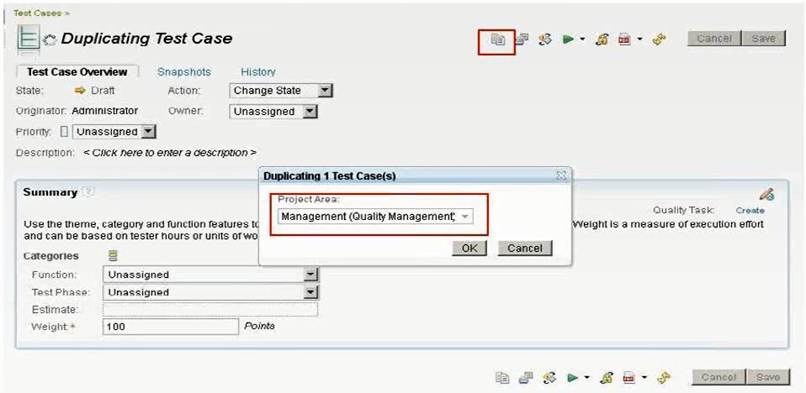

Duplicate allows you to copy multiple test artifacts by simply selecting the desired artifacts and choosing the copy all selected option.

## One Test Script per Test Case

RQM provides flexibility of attaching many test scripts to test cases for execution. However, at run time we can select any one of the test scripts to run.

It’s strongly recommended to use one test script per test case. Use more than one test script per test case only in the following scenario.

**Scenario:** Use more than one test script if you are running your test cases in different platforms like Linux, Windows etc. For example, your automation scripts may vary depending upon your operating system and underlining hardware and software. In this scenario you have to choose at execution time the test scripts which you plan to run in respective platforms.

## Entry criteria and Exit criteria

A Test Plan documents the planning of your test effort and its execution. The test plan can be configured to meet the needs of your team.

Test Plan provides two sections called Entry criteria and Exit criteria. These two criteria help to deliver a quality product and plan your deliverables accordingly.

Before you start your test plan execution, you can evaluate your entry criteria to determine whether it is complete and decide whether you can go for further testing or not. Similarly, you can use the exit criteria after your test execution is completed to determine whether your test plan is complete.

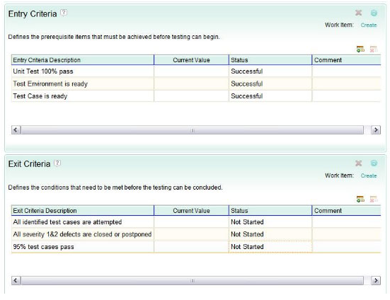

## Using Keywords, Test Data and Execution Variables

Keywords are nothing but reference points to execution steps. Once the step is written and assigned a keyword, it can be reused in other scripts by specifying the keyword. Using these keywords in several scripts helps to avoid re-writing the same script and/or steps in a script.

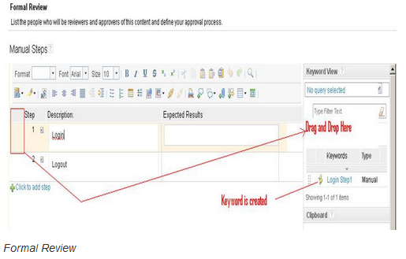

Test Data is simply a set of records written in a spread sheet and can be used as data in a manual test script. For example, the same script may be run for different sets of test data, sometimes called “data driven” testing.

Execution Variables are nothing but variables, whose values may change each time a script is run. These variables can be passed across different scripts. For example, in a login script, the login name can be stored in a variable and can be used in another script for finding out login details.

## Run Test Cases

There is several ways to run tests. Choose the methods and options that best suit your test team.

The simplest way to run a test is to run a test case. The test case can be associated with other test artifacts such as test plans, test scripts, test environments, test case execution records, and test suites.

When you run a test case, associate the test run with the context in which the test is run by assigning values for the test plan, iteration, and test environment. Although these associations are optional, many of the quality management reports are based on these values (which are stored in a test case execution record that is associated with the test case). If have not generated test case execution records prior to running the tests, and fail to assign these values in the Run Test Case dialog box while running a test case, the test run will not be reflected in your reports.

A test case often runs in the local environment. When the test run is finished, update the test case result, if necessary. If test execution needs are relatively basic and do not need to support multiple test environments, then it is easier to run test cases directly rather than creating and then running associated test case execution records.

## Run Test Suites

A test suite is a collection of test cases that are grouped for test execution purposes. Test suites can include test cases with both manual and automated test scripts, as well as test cases without associated test scripts, but test suites are most beneficial when creating a series of automated tests that run without supervision. When running a suite, specify whether to run the test cases in the suite sequentially or in parallel. With sequential suite execution, you can choose to stop the execution of the suite if a single test case does not pass. This is useful if running a test case in a test suite depends on the success of the previous test case.

## Run test case execution records and test suite execution records

Test case execution records and test suite execution records map the execution context to the test case or test suite. They specify the test plan, iteration and test environment for execution. You could define it in this way: Run this test case in this particular software and hardware environment and associate the test run with a specific test plan and test iteration. To ensure that test case or test suite is run in four different test environments, create a test case execution record or test suite execution record for each test environment.

Test case execution records and test suite execution records reflect the most recent test case result or test suite result (pass, fail, blocked) that is associated with the test case execution record or test suite execution record.

Create test case execution records and test suite execution records individually or use a wizard from within the test case or test suite to generate several at once automatically.

**Disclaimer**

Tech Mahindra, herein referred to as TechM provide a wide array of presentations and reports, with the contributions of various professionals. These presentations and reports are for informational purposes and private circulation only and do not constitute an offer to buy or sell any securities mentioned therein. They do not purport to be a complete description of the markets conditions or developments referred to in the material. While utmost care has been taken in preparing the above, we claim no responsibility for their accuracy. We shall not be liable for any direct or indirect losses arising from the use thereof and the viewers are requested to use the information contained herein at their own risk. These presentations and reports should not be reproduced, re-circulated, published in any media, website or otherwise, in any form or manner, in part or as a whole, without the express consent in writing of TechM or its subsidiaries. Any unauthorized use, disclosure or public dissemination of information contained herein is prohibited. Unless specifically noted, TechM is not responsible for the content of these presentations and/or the opinions of the presenters. Individual situations and local practices and standards may vary, so viewers and others utilizing information contained within a presentation are free to adopt differing standards and approaches as they see fit. You may not repackage or sell the presentation. Products and names mentioned in materials or presentations are the property of their respective owners and the mention of them does not constitute an endorsement by TechM. Information contained in a presentation hosted or promoted by TechM is provided “as is” without warranty of any kind, either expressed or implied, including any warranty of merchantability or fitness for a particular purpose. TechM assumes no liability or responsibility for the contents of a presentation or the opinions expressed by the presenters. All expressions of opinion are subject to change without notice.

**Thank You**

Visit us at [www.techmahindra.com](http://www.techmahindra.com)

Page Left Intentionally Blank